Western Australian Certificate of Education  
Final Examination, 2010

Question/Answer Booklet

|  |  |  |  |  |  |  |  |  |
| --- | --- | --- | --- | --- | --- | --- | --- | --- |
| **Student Number** : In figures: |  |  |  |  |  |  |  |  |

In words: ___________________________________

___________________________________

**HUMAN BIOLOGICAL SCIENCE STAGE 2**

**Time allowed for this paper**  
Reading time before commencing work: Ten minutes  
Working time for paper: Three hours

**Materials required/recommended for this paper**

***To be provided by the supervisor***This Question/Answer Booklet

Multiple-Choice Answer Sheet

Two 4-page Answer Booklets

***To be provided by the candidate***Standard Items: Pens, pencils, eraser or correction fluid, ruler, highlighter

Special items: Calculators satisfying the conditions set by the Curriculum Council for this subject

***Important note to candidates***No other items may be taken into the examination room. It is **your** responsibility to ensure that you do not have any unauthorised notes or other items of a non-personal nature in the examination room. If you have any unauthorised material with you, hand it to the supervisor **before** reading any further.

**Structure of this paper**

|  |  |  |  |  |  |
| --- | --- | --- | --- | --- | --- |
| Section | Number of questions available | Number of questions to be answered | Suggested working time (minutes) | Marks available | Percentage of exam |
| SECTION ONE:  Multiple-choice | 30 | 30 | 40 | 60 | 30 |
| SECTION TWO:  Short answer | 11 | 11 | 90 | 100 | 50 |
| SECTION THREE:  Extended answer | 4 | 2 | 50 | 40 | 20 |
|  |  |  |  |  | 100 |

**Instructions to candidates**

1. The rules for the conduct of Western Australian external examinations are detailed in the *Year 12 Information Handbook 2010*. Sitting this examination implies that you agree to abide by these rules.
2. Answer the questions according to the following instructions.

Section One: Answer all the questions on the separate Multiple-choice Answer Sheet provided. For each question shade the box to indicate your answer. Use only a blue or black pen to shade the boxes. If you make a mistake, place a cross through that square, do not erase or use correction fluid, and shade your new answer. Marks will not be deducted for incorrect answers. No marks will be given if more than one answer is completed for any question.

Sections Two: Write answers in this Question/Answer Booklet.

Section Three: Write answers in the separate 4-page Answer Booklets.

1. You must be careful to confine your responses to the specific questions asked and to follow any instructions that are specific to a particular question.
2. Spare pages are included at the end of this booklet. They can be used for planning your responses and/or as additional space if required to continue an answer.

* Planning: If you use the spare pages for planning, indicate this clearly at the top of the page.
* Continuing an answer: If you need to use the space to continue an answer, indicate in the original answer space where the answer is continued, i.e. give the page number. Fill in the number of the question(s) that you are continuing to answer at the top of the page.

**Section One: Multiple-choice 30% (60 Marks)**

This section has **30** questions. Answer **all** questions on the separate Multiple-choice Answer Sheet provided. For each question shade the box to indicate your answer. Use only a blue or black pen to shade the boxes. If you make a mistake, place a cross through that square, do not erase or use correction fluid, and shade your new answer. Marks will not be deducted for incorrect answers. No marks will be given if more than one answer is completed for any question.

The suggested working time for this section is 40 minutes.

________________________________________________________________________

1. Which of the following statements concerning cell membranes is true?
2. Water passes freely through the cell membrane using protein channels
3. A substance that is soluble in lipids will be repelled by the cell membrane
4. The size of a substance will not affect whether it passes through a cell membrane
5. Cell membranes allow all substances to pass through freely
6. Which of the following is not a component of the body’s external defence against disease?
7. Wax in the ears
8. Alkaline conditions in saliva
9. Layers of mucous in the respiratory tract
10. Acidic environment in the urethra
11. Which of the following statements about anaerobic and aerobic respiration is correct?
12. Anaerobic respiration requires oxygen and aerobic respiration does not
13. Aerobic respiration produces lactic acid while anaerobic respiration does not
14. Anaerobic respiration does not produce as much ATP as aerobic respiration
15. Anaerobic respiration produces carbon dioxide and water while aerobic respiration produces lactic acid
16. The process by which gas molecules move in and out of cells is called…
17. osmosis, a passive transport process
18. osmosis, an active transport process
19. diffusion, a passive transport process
20. diffusion, an active transport process

*The next question refers to the diagram below that shows four ways in which molecules may move into and out of a cell. The dots represent the concentration of molecules.*



**1**

**4**

**3**

**2**

1. If this cell is respiring aerobically, which arrow represents the movement of oxygen molecules?
2. 1
3. 2
4. 3
5. 4
6. If the respiratory and digestive systems were completely separate in humans, there would be no need for…
7. an epiglottis
8. a larynx
9. cartilaginous rings
10. the soft palate
11. Compared to inhaled air, exhaled air should contain a higher percentage of…
12. Oxygen, carbon dioxide and water vapour
13. Nitrogen, carbon dioxide and oxygen
14. Carbon dioxide and nitrogen
15. Carbon dioxide and water vapour

*The next three questions refer to the graphs below which depict the volume of air breathed in and out by a runner before and immediately after starting a race.*

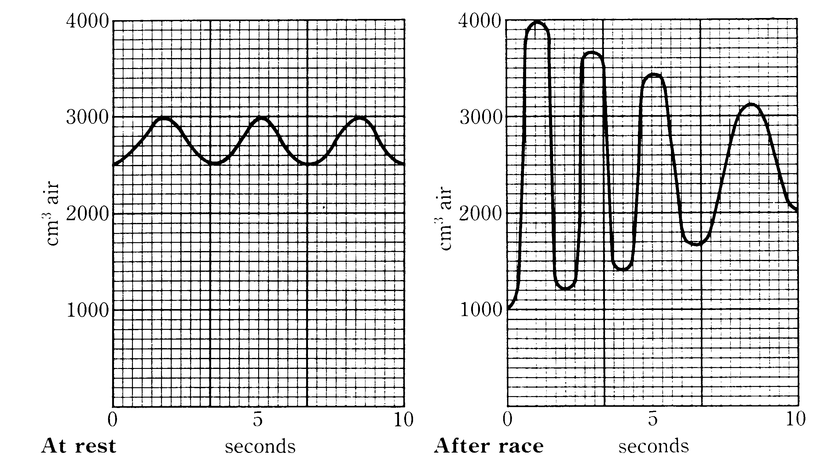

1. According to the graph above, how much air does the runner take in with each breath before the race?
2. 100 cm3
3. 300 cm3
4. 500 cm3
5. 3000 cm3
6. How many breaths does this runner breathe per minute before the race begins?
7. 18
8. 16
9. 12
10. 3
11. After the race, the runner…
12. only breathes more shallowly
13. only breathes faster
14. only breathes more deeply
15. breathes more deeply and faster
16. Antibiotics are used to fight infections. However, they have no effect on…
17. viruses
18. cocci and bacilli bacteria
19. spirilla bacteria
20. fungal diseases such as ringworm
21. The embryo is surrounded by the amniotic cavity, filled with amniotic fluid. This fluid…
22. Acts as a shock absorber
23. Provides a medium through which the exchange of materials takes place between the mother and embryo
24. Helps regulate a constant temperature
25. Produces hormones for the developing embryo
26. I and IV only
27. II and III only
28. I and II only
29. I and III only
30. In which of the following ways are human sperm and ova similar?
31. They have approximately the same mass
32. About the same number of each is produced
33. They are both motile
34. They have the same number of chromosomes
35. Red green colour blindness is a sex-linked recessive trait. If a colour-blind male and carrier female have one daughter, what is the probability that she is colour blind?
36. 0%
37. 25%
38. 50%
39. 75%
40. Co-dominance is a type of inheritance where…
41. Both allele are equally dominant and are expressed in the phenotype
42. There is blending of two or more alleles to create a mixed expression in the phenotype
43. Neither allele is dominant or recessive and cannot be expressed in the phenotype
44. Alleles are defective and are expressed as a congenital disorder in the phenotype
45. During the birth process…
46. Ligaments in the pubic bone relax
47. Secretion of oxytocin decreases
48. The endometrium contracts
49. The placenta detaches during the first stage of labour

Question 17 refers to the diagram of the nephron pictured below.

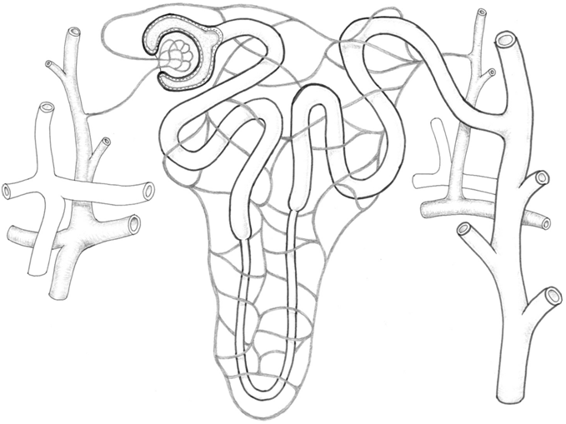

X

Y

A

C

D

B

C

1. Which of the following statements are true?
2. Hydrogen ions and some drugs are actively secreted into the filtrate at C
3. B is involved in the regulation of sodium and potassium
4. Filtrate at point A will contain less glucose than blood at point D
5. Urea is passively absorbed in A
6. A is the distal convoluted tubule
7. Blood at point Y will contain less urea than blood at point X
   1. (i), (ii), (iii) and (iv) only
   2. (i),(iv), (v) and (vi) only
   3. (i), (ii), (iv) and (vi) only
   4. (ii), (iii) and (vi) only
8. Which of the following best represents the end products of the process of digestion?
9. Glucose, amino acids, triglycerides
10. Monosaccharides, amino acids, fatty acids
11. Monosaccharides, polypeptides, fatty acids
12. Glycerol, amino acids, lipids
13. During pregnancy…
14. The embryo divides to form a thick protective tissue
15. Body organ formation begins during the 20th week of pregnancy
16. Fetal heart beat can be detected during the 12th week of pregnancy
17. The arms and legs of the fetus are formed towards the end of pregnancy
18. Consider the table below, which indicates the parts of the digestive tract where chemical digestion of various foods occurs. An X indicates a positive result.

|  |  |  |  |  |
| --- | --- | --- | --- | --- |
| Section of digestive tract | Food 1 | Food 2 | Food 3 | Food 4 |
| Mouth | **X** |  |  |  |
| Stomach |  | **X** |  |  |
| Small intestine | **X** | **X** | **X** |  |

Which food is most likely to be a piece of meat?

1. Food 1
2. Food 2
3. Food 3
4. Food 4
5. Which of the following statements about DNA is not correct?
6. During transcription DNA is copied to RNA
7. The four bases in DNA are represented by the letter A, T, G and C
8. The bases A and C pair together
9. DNA is coiled around proteins called histones
10. Some people have ethical concerns over the use of the morning after pill and the IUD as forms of contraception. This is because these methods…
11. Disrupt the female’s menstrual cycle
12. Do not prevent fertilization occurring
13. Are expensive and difficult to administer
14. Only protect against some STIs
15. A woman who has heavy scarring to her uterus and has had several miscarriages in the last few years wants to have a baby. Which reproductive technology would be suited to her?
16. Artificial insemination
17. Donor embryo
18. In vitro fertilization
19. Surrogacy

The next question refers to the following diagram of a karyotype image of an individual’s chromosomes.

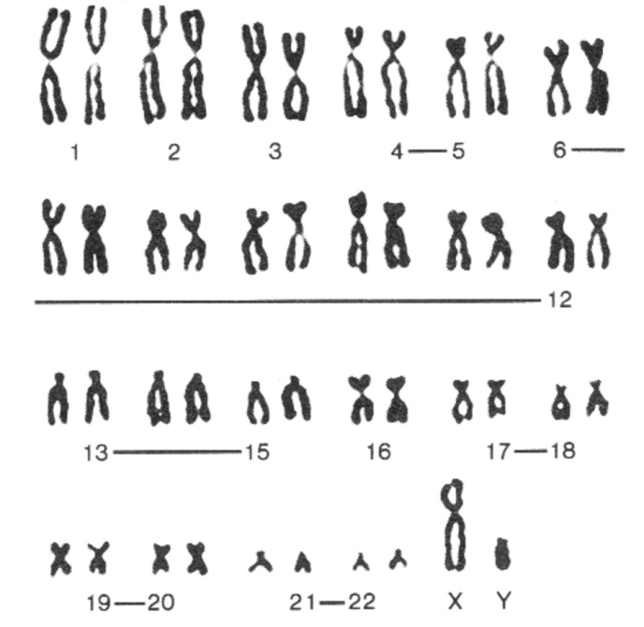

1. The individual is a …
2. Female with trisomy
3. Female with mutations
4. Male with monosomy
5. Male with a normal number of chromosomes
6. Emulsification of fat…
7. Is a form of mechanical digestion
8. Is brought about by pancreatic lipase
9. Requires an acidic environment
10. Is a form of chemical digestion

The next question refer to the following diagram of the heart.

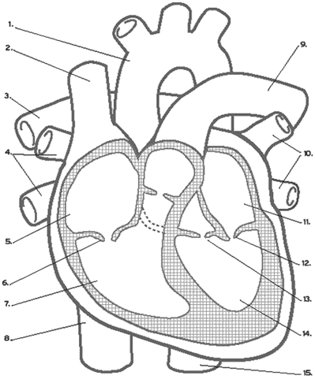

1. The correct names for the parts identified above are…
2. 1 = aorta, 5 = right ventricle, 9 = pulmonary artery
3. 11 = right atrium, 10 = pulmonary veins, 2 = superior vena cava
4. 1 = aorta, 8 = inferior vena cava, 9 = pulmonary vein
5. 2 = superior vena cava, 6 = tricuspid valve, 9, = pulmonary artery
6. The lung disease emphysema is characterised by a breakdown of alveoli membranes. This results in fewer but larger air sacs. Lung function is therefore affected because:
7. The alveoli membranes are thinner and diffusion occurs faster
8. More air can be inhaled during inspiration
9. There is less surface area of alveoli for gas exchange
10. The alveoli tend to dry out reducing the diffusion rate
11. Below is an image of several Euglena taken with a light microscope. The magnification of this image is 7000 times.

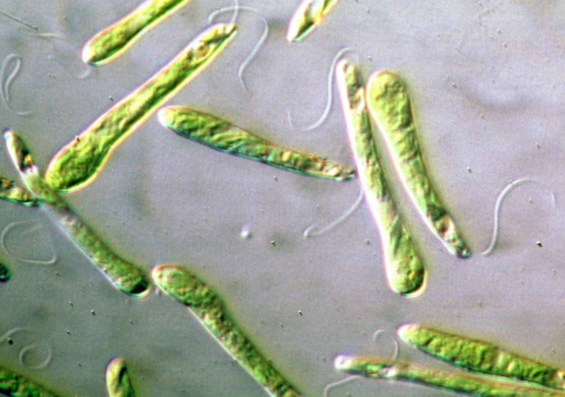

The average length of the Euglena (excluding the flagellum) is closest to…

1. 32 mm
2. 3200 µm
3. 0.045 mm
4. 4.5 µm
5. A blood clot is formed when…
6. the threads of insoluble proteins contract
7. sufficient clotting factors are present to bind the blood cells together
8. the threads of insoluble protein form a meshwork trapping blood cells, platelets and plasma
9. platelets form an insoluble plug or clot on top of the affected area
10. Which of the following is the difference between active transport and facilitated diffusion?
11. Facilitated diffusion involves membrane proteins but active transport uses plasma proteins
12. Facilitated diffusion requires energy and active transport is energy neutral
13. Active transport involves membrane proteins but facilitated diffusion does not
14. Active transport requires energy from the cells and facilitated diffusion is energy neutral

**Section Two: Short answer 50% (100 Marks)**

This section has 11 questions. Answer **all** questions. Write your answers in the spaces provided.

Spare pages are included at the end of this booklet. They can be used for planning your responses and/or as additional space if required to continue your answer.

* Planning: If you use the spare pages for planning, indicate this clearly at the top of the page.
* Continuing your answer: If you need to use the space to continue an answer, indicate in the original answer space where the answer is continued, i.e. give the page number. Fill in the number of the question(s) that you are continuing to answer at the top of the page.

The suggested working time for this section is 90 minutes.

________________________________________________________________________

**Question 31 (9 marks)**

1. Name one sexually transmitted infection (STI) caused by bacteria and one STI caused by a virus. For each, describe the symptoms and possible treatments for the infection.

(6 marks)

Bacteria

Name of STI: _____________________________________

Symptoms

Treatment

Virus

Name of STI: _____________________________________

Symptoms

Treatment

1. Describe three strategies that people can practice that help to prevent the transmission of STIs.

(3 marks)

**Question 32 (10 marks)**

Immediately following fertilization, the zygote begins to divide to form a solid ball of cells. As cell division continues, the cells arrange themselves into a hollow ball as seen in the micrograph image shown below.

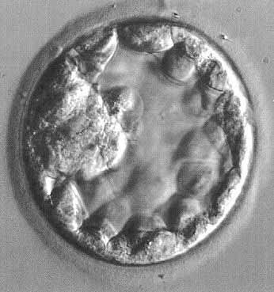

(a) What is the name given to this ball of cells?

(1 mark)

(b) What is a stem cell?

(1 mark)

(c) Identify two distinct sources of stem cells in the human body?

(2 marks)

(d) During the early development of the embryo, three primary germ layers are formed. State which of the three primary germ layers will be differentiated into the cells and tissues shown in the table.

(2 marks)

|  |  |
| --- | --- |
| Cells or tissues | Primary germ layer |
| Skeletal muscle  Red blood cells |  |
| Neurons of the brain  Hair and fingernails |  |

(e) What is a teratogen? Give an example of a teratogenic agent.

(2 marks)

(f) Identify and describe one medical technique that doctors can use to diagnose foetal health inside the mother’s uterus.

(2 marks)

**Question 33 (9 marks)**

(a) Describe the three ways in which carbon dioxide is transported in the blood

(3 marks)

(b) Which one of the three ways identified in part (a) is the main way in which carbon dioxide is carried in the blood?

(1 mark)

(c) A woman accidently pricked her right thumb when trimming a rose plant. The injured area became swollen, red and slightly tender to touch.

(i) What is this reaction to injury called?

(1 mark)

(ii) Explain why the injured tissue becomes swollen and red.

(4 marks)

**Question 34 (10 marks)**

The following graph shows the concentration of the hormones in a female’s blood during one menstrual cycle.

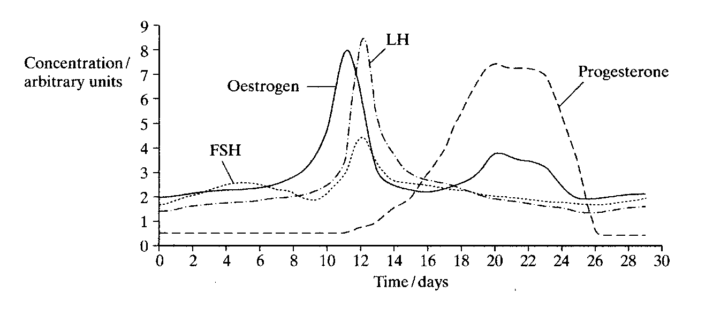

(a) On which day is ovulation most likely to have occurred? Give one piece of evidence from this graph that supports your answer.

(2 marks)

(b) Progesterone ‘peaks’ at Day 20. What is the function of increased progesterone levels?

(1 mark)

(c) What structure is responsible for this high level of progesterone secretion?

(1 mark)

(d) Explain why the level of progesterone falls between days 24 and 26.

(1 mark)

(e) Below is a section from a pamphlet that comes with a home pregnancy test. Read it and then answer the questions that follow.

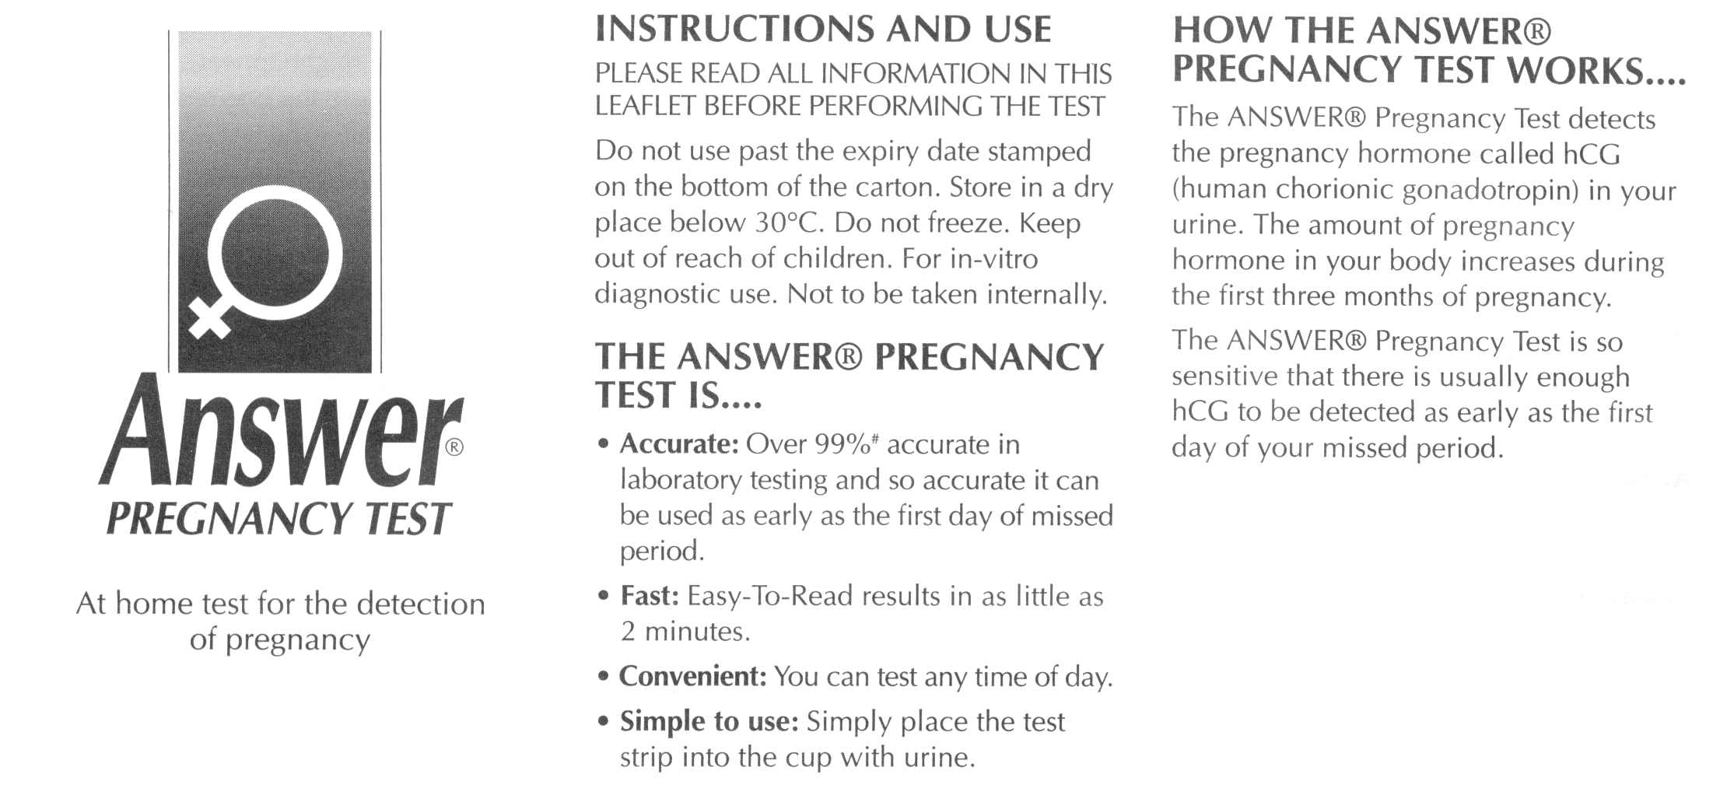

(i) The test claims to be 99% accurate in laboratory testing. Give one reason why it may not be so accurate when used in the home.

(1 mark)

(ii) Explain why hCG is a reliable indicator that a woman is pregnant.

(2 marks)

(iii) Another section of the pamphlet (not included above) states that a pregnant woman should limit her consumption of alcohol. Explain why this is good advice.

(2 marks)

**Question 35 (9 marks)**

The diagram below shows some parts of the male reproductive and urinary system.

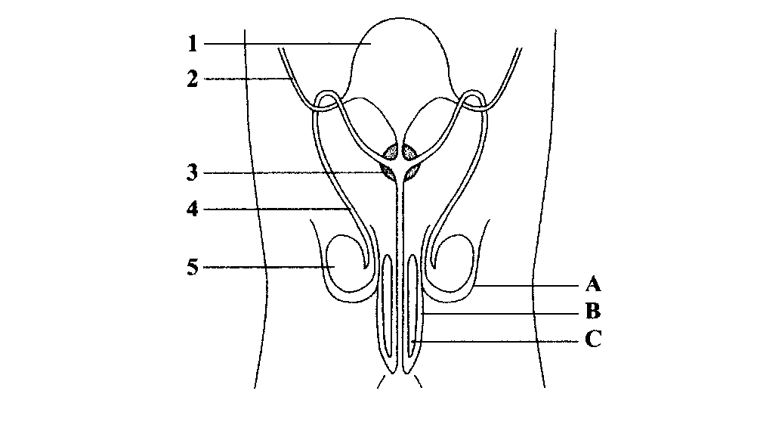

(a) Complete the following table using the above diagram.

(3 marks)

|  |  |
| --- | --- |
| Label | Structure |
| 2 |  |
| 4 |  |
| A |  |

(b) During intercourse live and mature sperm are released near the cervix in the female in anticipation of fertilisation. Describe the functions of the structures listed below.

(3 marks)

(i) Epididymis

(ii) Seminal vesicle

(iii) Penis

(c) Some couples choose to prevent fertilisation by using one or several contraceptive devices. Select three contraceptive devices and clearly explain each how device prevents fertilisation.

(3 marks)

|  |  |
| --- | --- |
| Contraceptive Device | How it Prevents Fertilisation |
|  |  |
|  |  |
|  |  |

**Question 36 (10 marks)**

The following pedigree shows the inheritance of Huntington’s Disease over four generations. In each generation (I, II, III, etc) individuals are identified by numbering from the left to right across the pedigree (I.1, I.2, I.3, etc).

**I**

**II**

**III**

**IV**

(a) Individual II.4 is the first individual in his family to be affected by Huntington’s Disease. What must have happened to cause this condition?

(1 mark)

(b) Indicate whether the allele for Huntington’s Disease is dominant or recessive.

(1 mark)

(c) From the evidence in the pedigree, state whether this condition is transmitted on an autosomal chromosome or a sex chromosome.

(1 mark)

(d) Explain how you arrived at your answer to (c).

(2 marks)

(e) Using ‘A’ to indicate dominant and ‘a’ to indicate recessive alleles, what is the genotype of individual III.3?

(1 mark)

(f) III.4 and III.5 are expecting another child. What is the probability that their fourth child will have the affected phenotype? Show your working.

(2 marks)

(g) Describe two symptoms of an individual suffering from Huntington’s Disease.

(2 marks)

**Question 37 (10 marks)**

Read the text below which describes the results of a scientific investigation and then answer the questions on the next page.

**Chocolate milk wins battle of the sports drinks**

20 Apr 2009

Whether you're kicking off the new footy season, or sweating it out at the gym – chocolate milk could be your new best friend. In a post-exercise energy recovery trial that pitted chocolate milk against commercial sports drinks, childhood favourite – chocolate milk – has taken first place.

Researchers from England's Northumbria University recently compared the effects of three beverages on performance in a cycling endurance test.1 The three beverages were chocolate milk, a commercially available sports drink, and a commercially available fluid replacement drink.

On three occasions, nine trained male cyclists completed a glycogen depletion workout, drank one of the three test beverages during a four-hour recovery period, and then cycled in an endurance capacity trial.

When the cyclists were given chocolate milk, they were able to cycle 51 percent longer in the endurance test before exhaustion than they did when they were given the sports drink and 43 percent longer than when they were given the fluid replacement drink.

The researchers noted that participants cycled longer after drinking chocolate milk than after sports drink, despite the beverages having very similar calorie (or energy) contents.  They said the difference could be due to differences in carbohydrate type and (or) fat content between the beverages.

Dairy Australia dietitian Glenys Kerrins said: "Milk is a sports drink plus a whole lot more. Being about 90% water, it is ideal for re-hydration and contains an ideal natural mix of carbohydrate and protein to help refuel tired bodies. Plus it packs a nutritional bonus of calcium and seven other essential nutrients (including potassium, phosphorus, vitamins A, D and B12, riboflavin and niacin)."

Ms Kerrins says that the study demonstrates that expensive supplements are not necessarily better than great tasting whole foods when it comes to athletic performance.

"Milk is something most people have in their fridge. It's easy, doesn't cost a lot and it's got everything you need after a workout," Ms Kerrins said.

**References**

1. Thomas K, et al. (2009) Improved endurance capacity following chocolate milk consumption compared with 2 commercially available sport drinks *Appl Physiol Nutr Metab*;34:78-82.

(a) Identify the independent variable in the experiment described in the previous article.

(1 mark)

1. What was the dependent variable in the experiment?

(1 mark)

1. How could the reliability of this experiment be improved?

(1 mark)

1. Identify two control variables that are mentioned in the article above.

(2 marks)

1. List two more variables that should have been controlled to ensure a fair experiment.

(2 marks)

1. The design of this experiment does not include a separate control group for comparison. How have the researchers compensated for the lack of a control group?

(1 mark)

1. Potentially the results of this experiment could have been influenced by the placebo effect. Discuss the placebo effect with reference to this experiment.

(2 marks)

**Question 38 (9 marks)**

A cellular biologist carried out an investigation into which factors affect enzyme action. She measured the time it took for an enzyme to break down a substance (substrate) at different temperatures. During the experiment she kept the pH of the solution constant. Her results are shown in the graph below. At temperatures greater than 50oC the enzyme was unable to breakdown the substrate.

(a) Explain why the time taken to break down the substrate increases after 40oC.

(2 marks)

(b) In a second similar experiment, the biologist decided to investigate the effect that pH would have on the effectiveness of the same enzymes. On the axes below, sketch in a graph that would represent the data collected by the biologist in her second experiment. Also label the axes.

(2 marks)

Metabolism (the sum of all the chemical changes that occur in a living organism) falls into two parts: **anabolism,** which consists of energy-requiring reactions involving synthesis of complex molecules, and **catabolism** consisting of energy-yielding reactions in which complex molecules are broken down.

**ATP** is the link in the **transfer of energy** from catabolic reactions to the anabolic ones.

The diagram below is based on the information in the above paragraph.

Simple

molecules

Complex

molecules

Complex

molecules

Simple

molecules

2

ADP + P

4

1

3

(c) For the boxes 1 to 4 give the appropriate term from the **bold** print in the passage at the top of the page.

(4 marks)

Box 1: _______________________________________

Box 2: _______________________________________

Box 3: _______________________________________

Box 4: _______________________________________

(d) The human body produces ATP at a rate of approximately 400g/hour, yet at any given moment there is only about 50g of ATP present in the body. Explain why.

(1 mark)

**Question 39 (8 marks)**

The diagram below shows the process of filtration in the kidney.

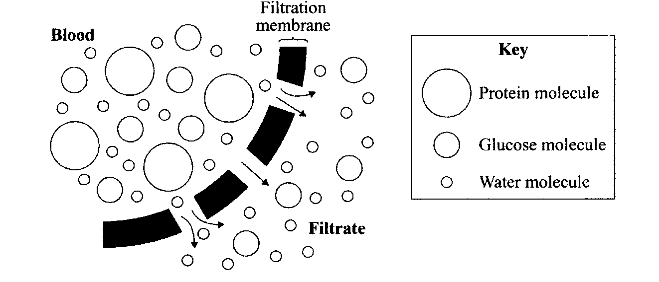

(a) Use the diagram to explain why protein molecules are not normally present in urine.

(2 marks)

(b) Explain why glucose molecules are found in the filtrate but are not normally found in the urine?

(2 marks)

(c) Name a disease that would cause glucose to be found in the urine.

(1 mark)

(d) Describe the normal composition of urine?

(3 marks)

**Question 40 (9 marks)**

Below is a schematic diagram showing the transport of simple molecules across the intestinal wall.



(a) In the three spaces provided write in the form of membrane transport involved in moving each type of molecule into the intestinal epithelium.

(3 marks)

(b) Explain how the immediate destination of the molecules at A and B is different from that of the molecule at point C.

(2 marks)

(c) The hepatic portal vein carries blood from the small intestine to the liver. The mesenteric artery carries blood to the small intestine. Describe the difference in the glucose, amino acid, oxygen and carbon dioxide concentration in each of these blood vessels.

(4 marks)

**Question 41 (7 marks)**

Cystic fibrosis is the most common genetic disease among people of European descent. It is almost always caused by the deltaF508 deletion mutation.

(a) What is a mutation?

(1 mark)

(b) Name and describe three types of mutations, other than a deletion.

(6 marks)

**Section Three: Extended answer 20% (40 Marks)**

This section contains **four** questions. You must answer **two** questions. Write your answers in the separate 4-page Answer Booklets.

Responses could include clearly labelled diagrams with explanatory notes; lists of points with linking sentences; clearly labelled tables and graphs; and annotated flow diagrams with introductory notes.

Suggested working time for this section is 50 minutes.

________________________________________________________________________

**Question 42**

The body requires different nutrients from the diet to supply the special requirements to the body.

(a) Identify the five nutrient groups required by the body and describe the general function for each one.

(10 marks)

(b) Enzymes in the digestive system play a key role in allowing the body to utilise these nutrients. What is an enzyme? Identify four digestive enzymes describe the action of each, including the specific products that are produced.

(10 marks)

**Question 43**

1. Outline the path taken by the ovum and sperm through the reproductive systems, from the point of formation of both to the creation of the zygote. Include the names of the events that occur along the path.

(12 marks)

1. Explain the purpose of meiosis and describe how it is different from mitosis.

(8 marks)

**Question 44**

(a) Blood is composed of plasma and a non-liquid component called ‘formed elements’. Describe the composition of plasma and the structure of the formed elements.

(6 marks)

(b) Describe the vessels that carry blood to and from the heart.

(4 marks)

(c) Identify the structures that have a role in the movement of air into the lungs. Describe the role played by each structure.

(10 marks)

**Question 45**

During pregnancy, a number of significant developments occur to facilitate a successful pregnancy. These developments and changes involve both mother and baby.

(a) What is the placenta? Describe its role during a pregnancy.

(4 marks)

(b) During pregnancy, the mother will experience a number of changes to her body to allow the baby to grow, give birth and provide postnatal care. Describe **FOUR** changes to the mother.

(8 marks)

(c) Discuss the changes that occur to a foetus’ circulatory system as it is born.

(8 marks)

**END OF EXAMINATION**